The dismantling process
The tools used included;
- Screw driver

First, we made sure the computer was powered off and all cables were unplugged.
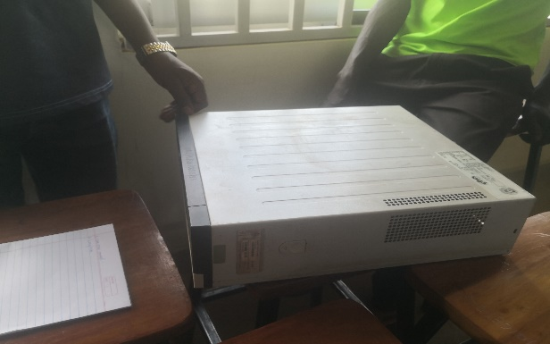

Then, we pressed the locks on the sides of the computer and carefully removed the cover of system case to have access to components inside.
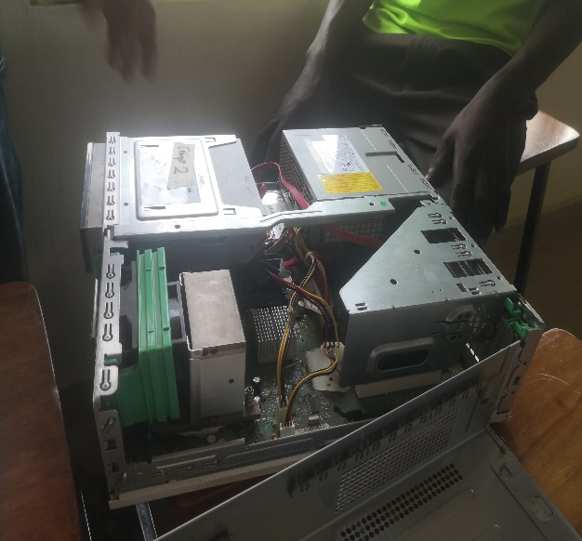
View of process of removing the cover view of the inner parts of the computer
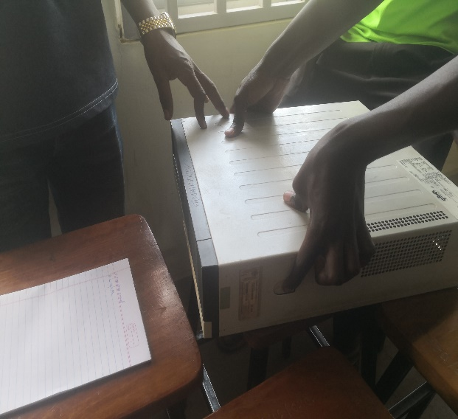

Next, we detached the data and power cables from the disk drive and pulled it out.
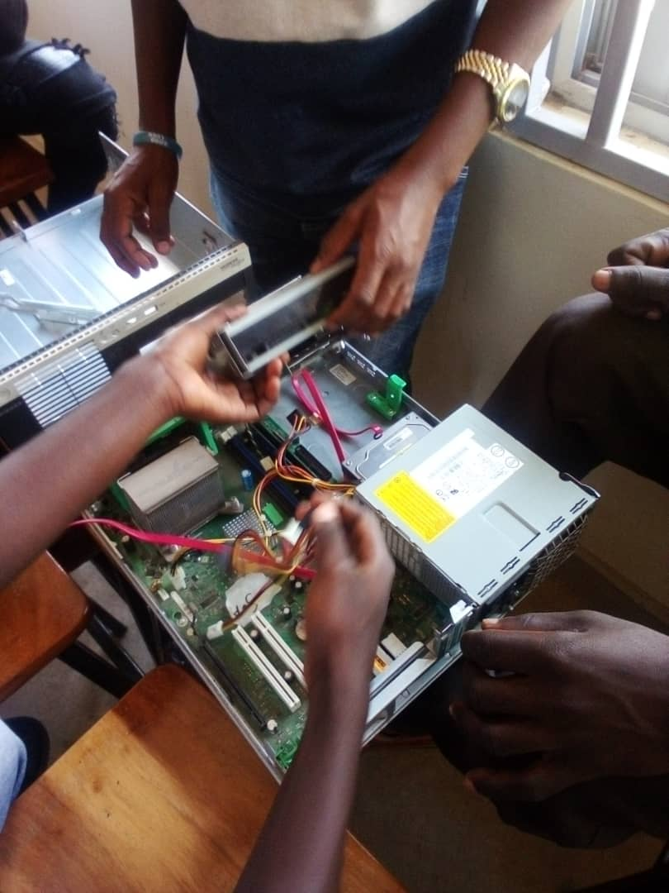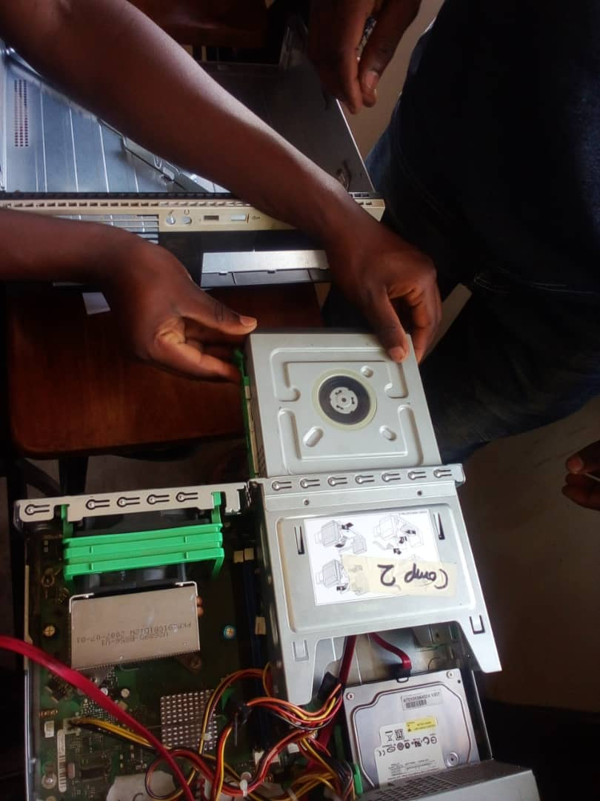
We then removed the RAM chips by pressing down on the clips and pulling them out gently.
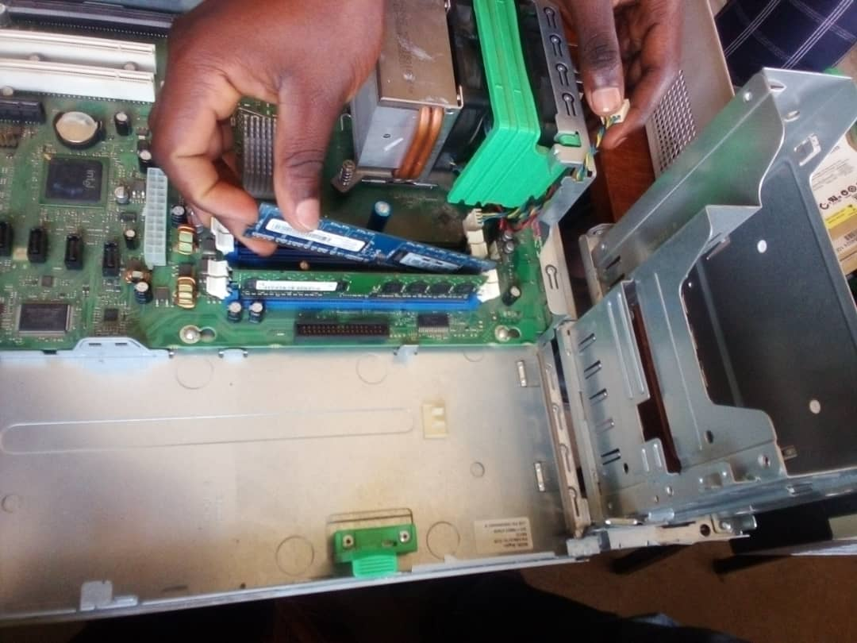
We unplugged the power supply and all connected cables from it, motherboard and hard disk which was then plugged out gently.
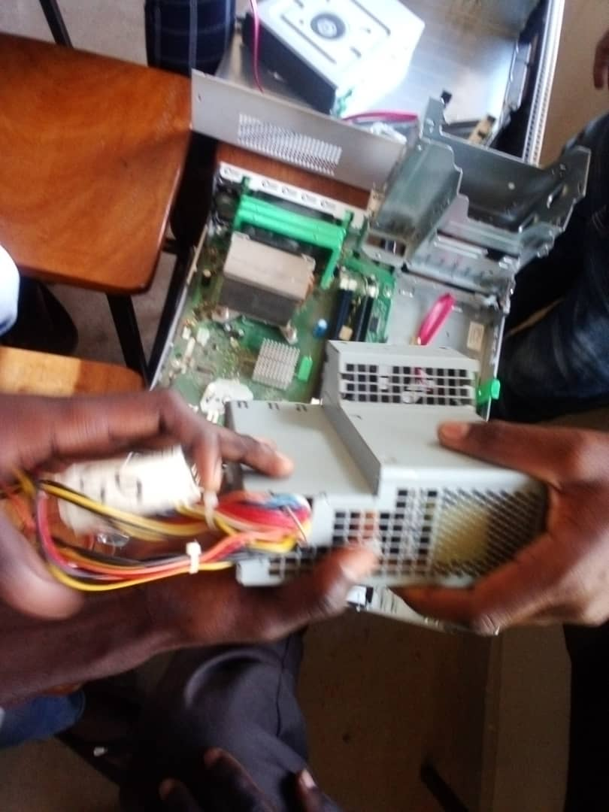

The hard disk was then plugged out gently
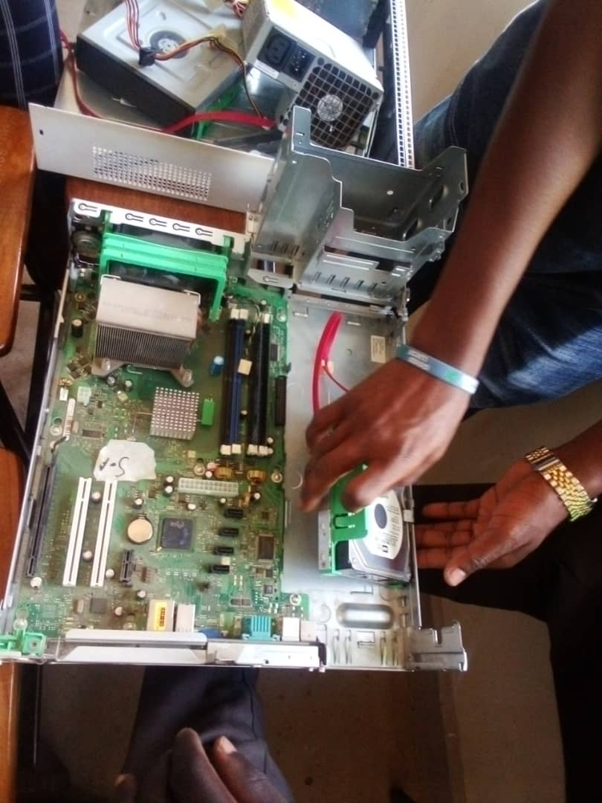
Moving on to the motherboard, we unscrewed the back part. Then we carefully slid the motherboard backward to unlock it from the system case then lifted it out of the case, making sure not to damage any components.

